River Schenck

Chibuike Chikere-Njoku

Skyler Judson

HW 13

expl10.4 (read-only)

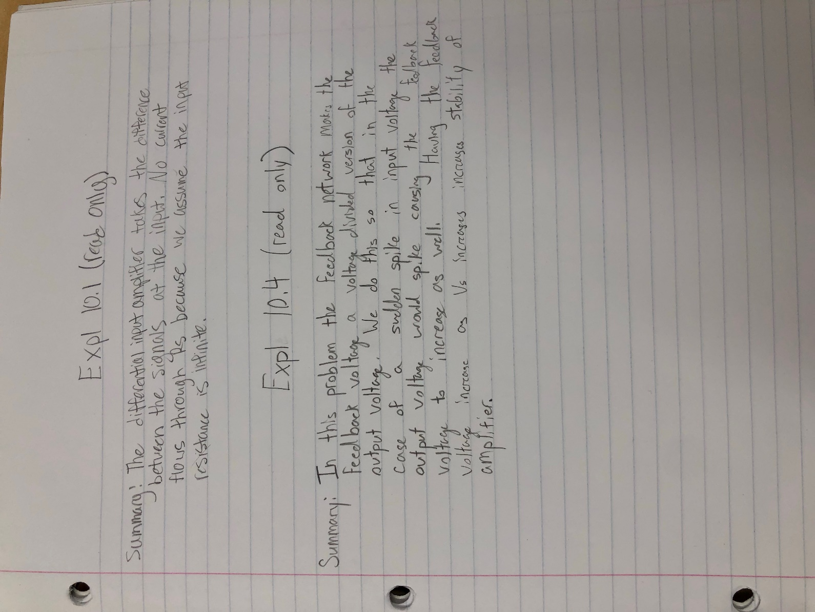

p10.31: Series-shunt feedback amplifier

p10.36 (simulate): Series-shunt feedback amplifier with BJTs

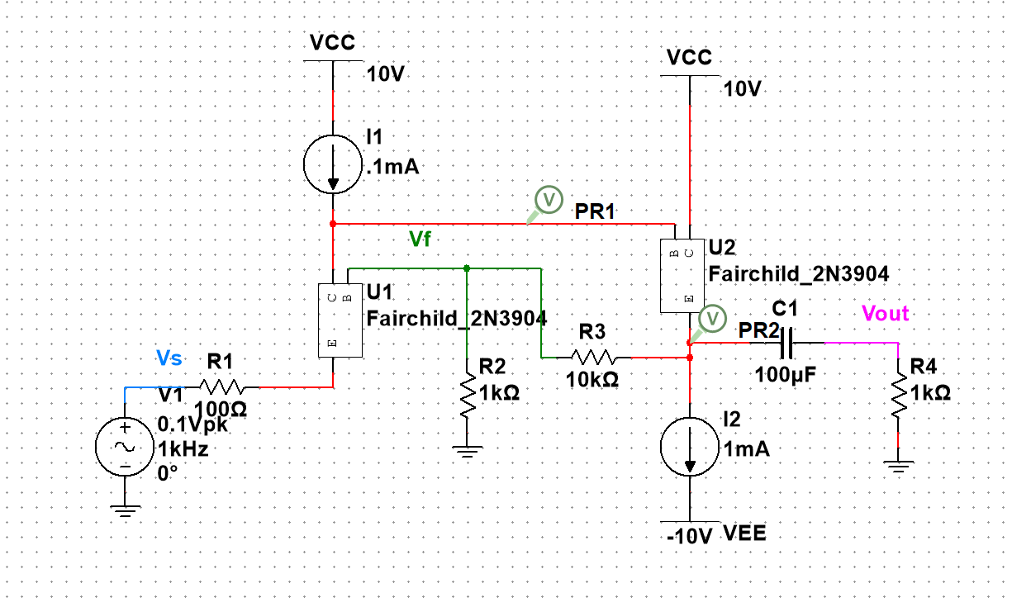

Af = 10.6 V/V

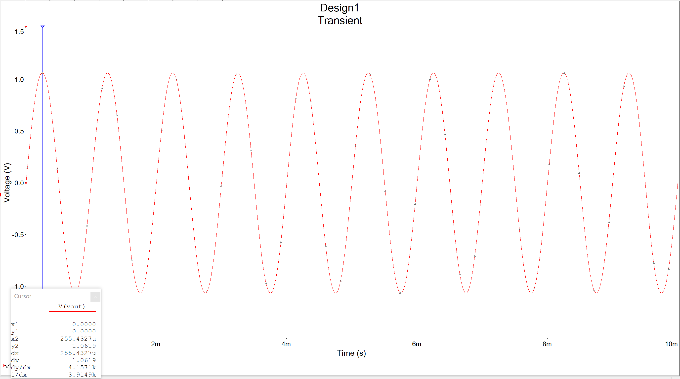

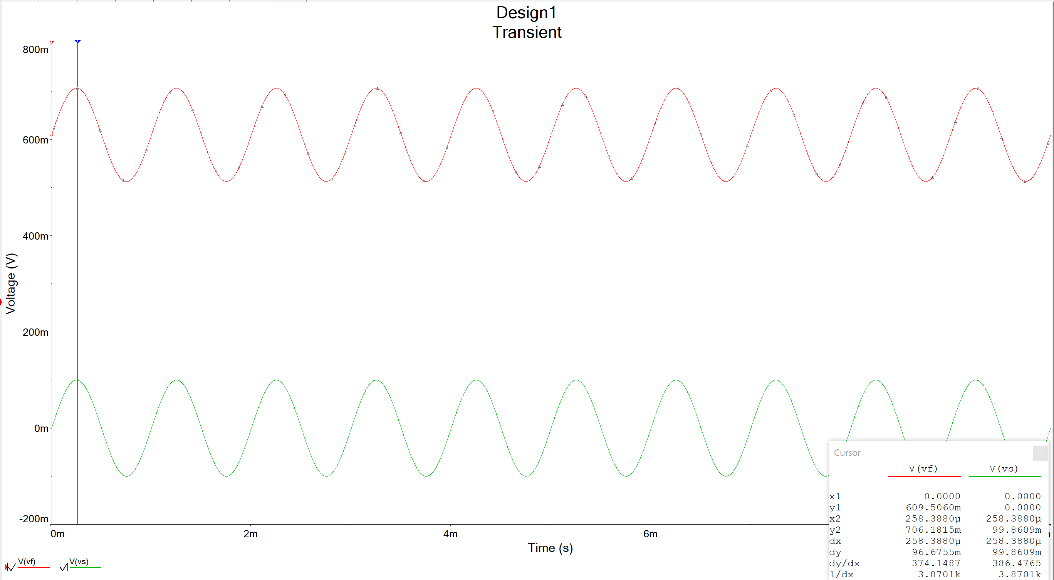

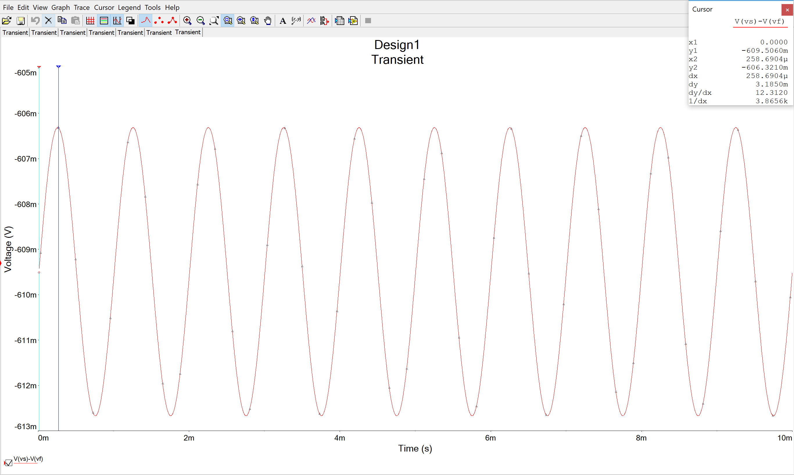

p10.39 (simulate): Series-shunt feedback in active-loaded differential amplifier with MOSFETs

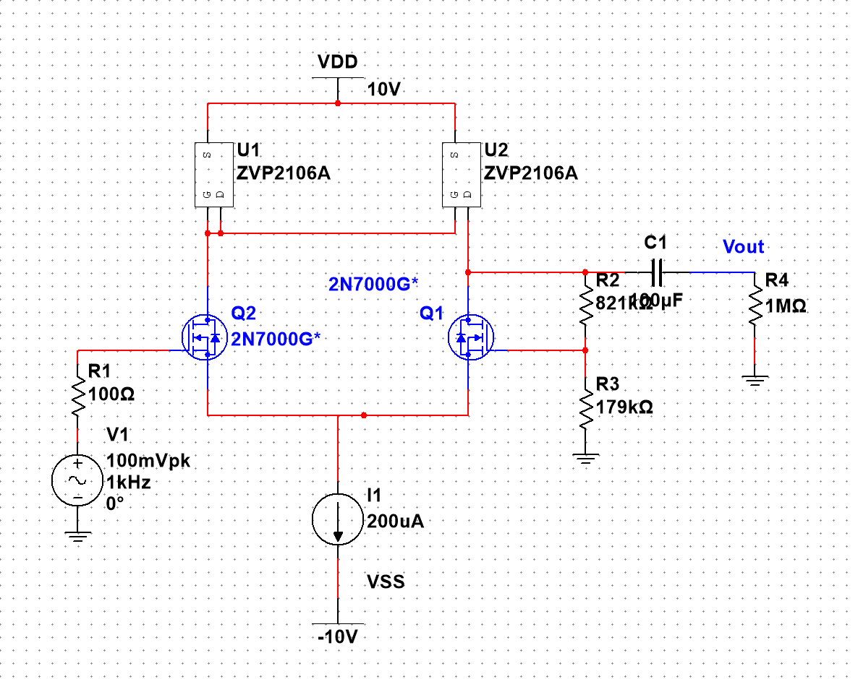

Af(1M) = 4.84 V/V

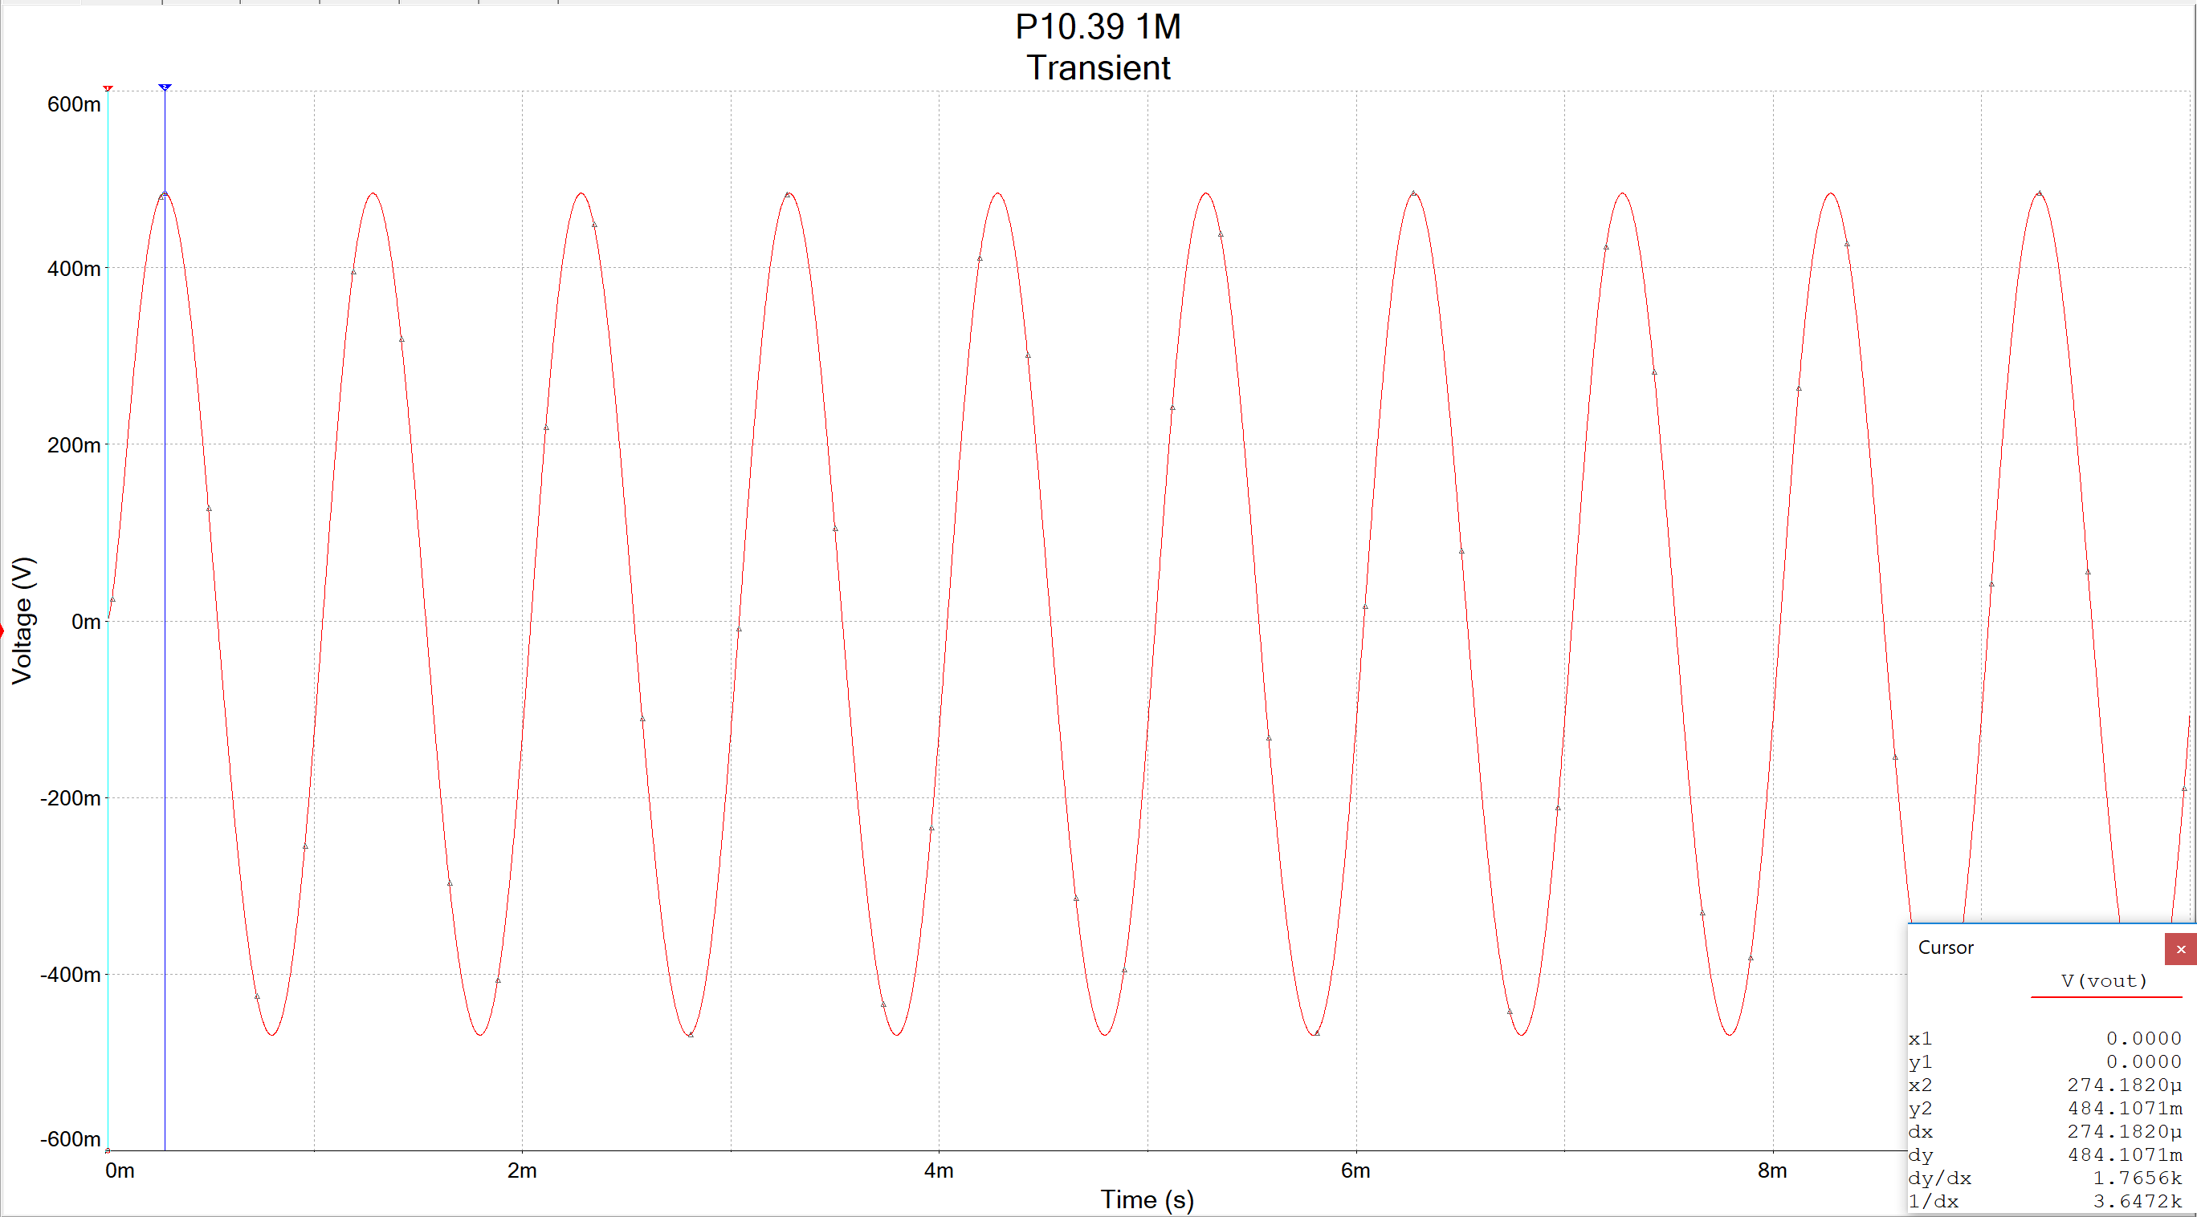

Af(20k) = 2.8 V/V

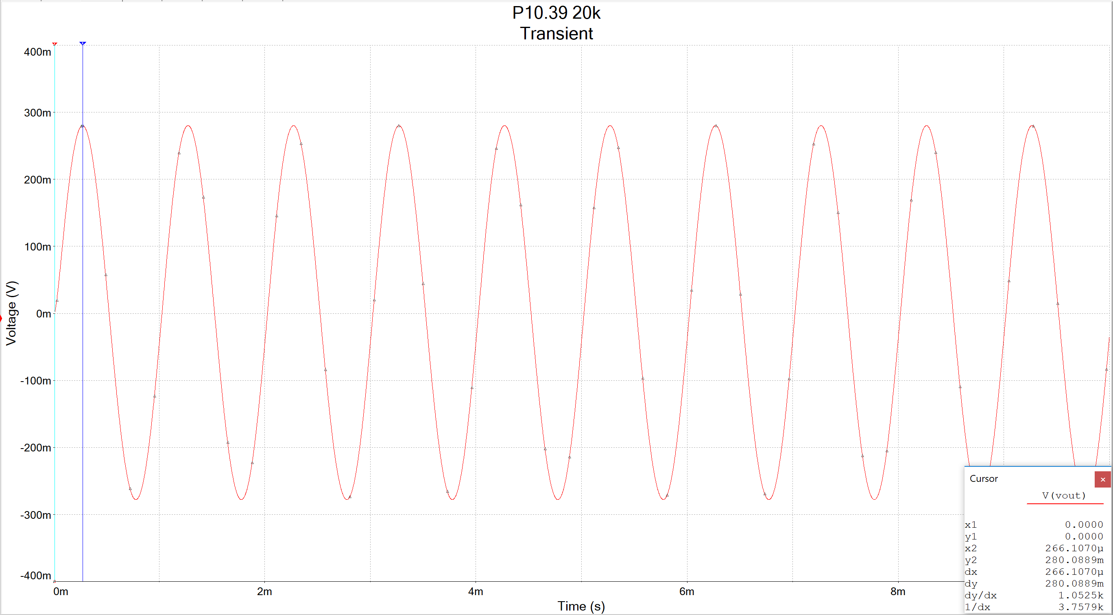

Vf vs. Vin

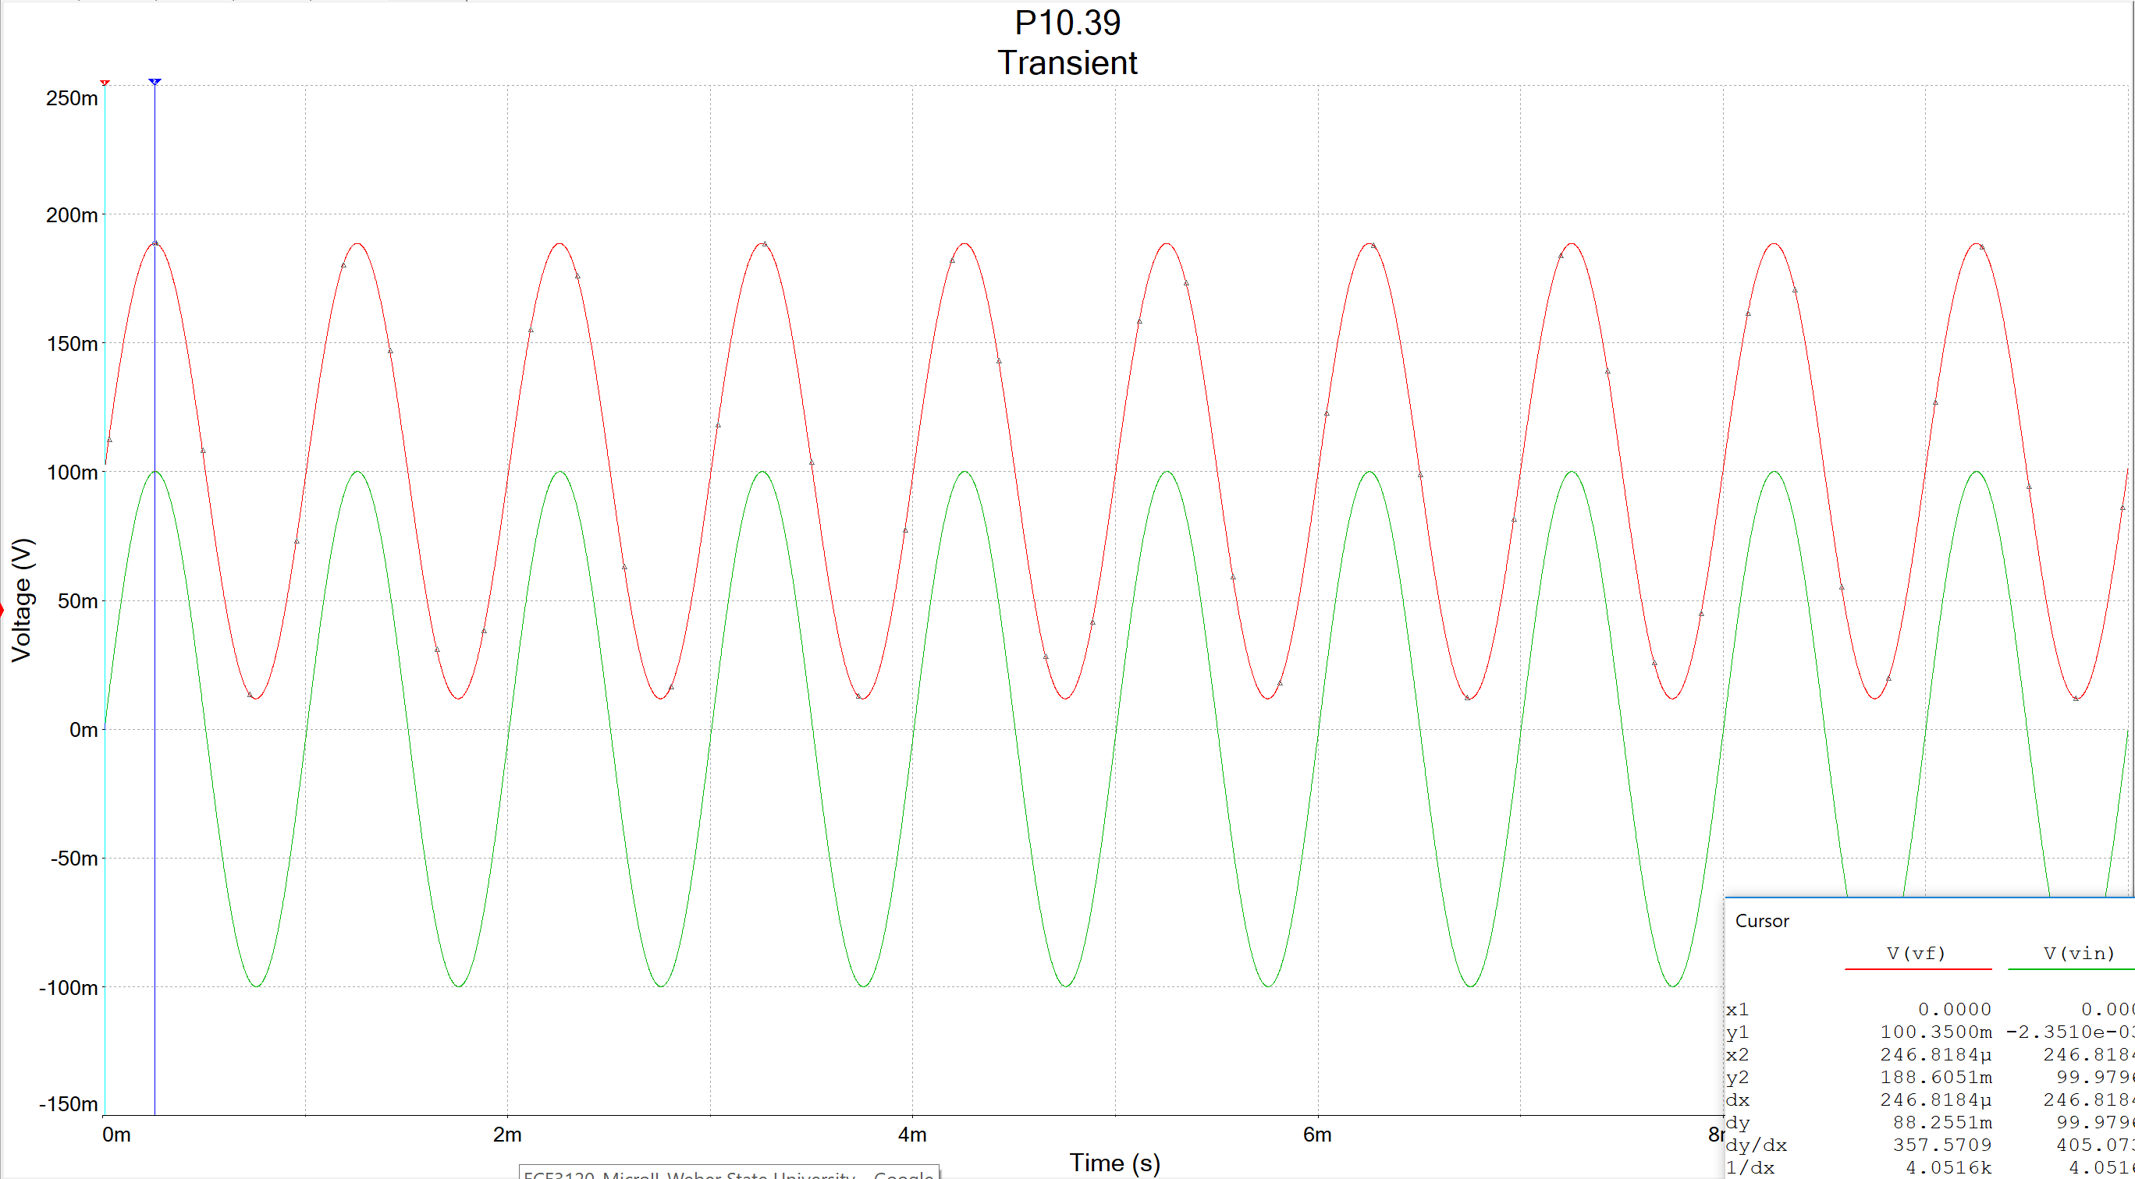

Difference in Vs and Vf

